# Exfloat Technology Development

## AquaMetrix Model ES-5 Series Conductivity SensorsAquaMetrix ES-5 Toroidal Conductivity Sensor

* Cost: $600.00
* Goal: Test Low-Cost, COST conductivity sensor for oceanographic applications
* Why: Toroidal sensors more resistant to biofouling and may simplify calibration procedures for low-cost applications
* Why: Frequently used in industrial applications; may or may not provide absolute accuracy necessary for oceanographic research
* Features: Standard 4-20mA output, temperature compensated, rated for pressures at 70+m
* <https://www.instrumart.com/products/40329/aquametrix-model-es-5-series-conductivity-sensors>

## C:\Users\langis\Desktop\rockblock2-1.jpgRockBLOCK MK2 (Iridium Modem)

* Cost: $279.00
* Cost: Optional $64.00 for patch antenna
* Goal: Test reliability, ease of use, power consumption, and programming for very low-cost iridium module
* Why: Iridium is a proven, reliable method of providing 2-way global communication with devices; must test feasibility of integrating COST modem for rapid prototyping projects.
* Features: Small (3”x2”x0.75”), lightweight (76g), pre-written libraries for programming with Arduino boards.
* <https://www.rock7mobile.com/products-rockblock.php>

## Sensonor SW412-13 (MEMS Pressure Sensor)

* 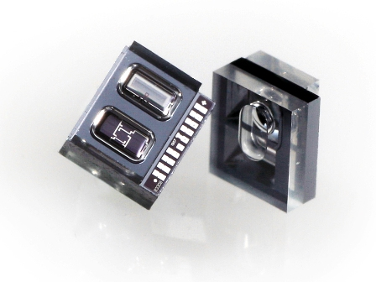Cost: ~$15.00
* Goal: Test low-cost pressure sensor for oceanographic applications
* Why: MEMS (Micro Electro-Mechanical Systems) are becoming more prevalent and provide low cost, COST products
* Why: SW412-13 is widely used in industry + medical applications; has not yet been tested in salt water, but should work fine in such an environment
* Features: Rated to 13 bar (~130m depth), 0.11% non-linearity, non-linearity decreases with pressure (more accurate at very small depths), bridge sensor which can be integrated into a variety of analog-to-digital converters
* <http://www.sensonor.com/pressure-products/pressure-sensors/sw412-13.aspx>

## http://www.zmdi.com/sites/default/files/product-image/Vorlage_Dashboard_220x220px_0.pngZSSC3018 (Sensor Signal Conditioner)

* Cost: ~$3.00
* Goal: Test Ultra low-cost sensor signal conditioner for high resolution, high accuracy bridge sensors (Temperature and Pressure)
* Why: Traditional sensors require complex circuits to “condition” outputs to provide a repeatable, accurate signature. New technology (ZSSC3018 just released Dec 1, 2015) integrates highly complex functions into a single ultra-low cost IC.
* Why: Reduced circuit complexity allows for dramatically reduced design costs, rapid prototyping, and thus ultra-low cost sensors; applicable to Temperature and Pressure/Depth for oceanography
* Features: “True” 18-bit analog-to-digital converter: Typical sensor elements can achieve accuracy of better than 0.01% Full Scale Output with *no other circuitry*, low power (1 mA), tiny (4mm x 4mm), built in temperature sensor with 0.003K resolution
* 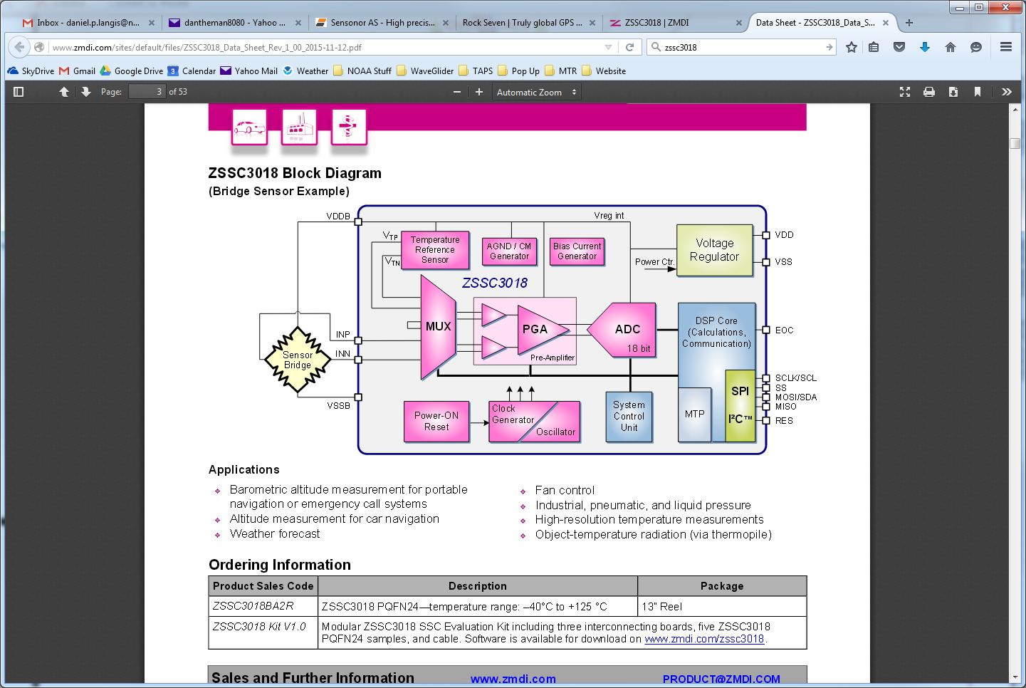<http://www.zmdi.com/zssc3018-0>

## Adafruit Ultimate GPS Breakout - 66 channel w/10 Hz updates - Version 3Adafruit Ultimate GPS Breakout

* Cost: $39.95
* Cost: Optional $12.95 for external antenna
* Goal: Test reliability, ease of use, power consumption, and programming for very low-cost GPS module
* 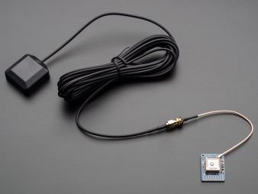Why: GPS is inexpensive, reliable, and ideal for transmitting locations from remote areas such as for Exfloat after surfacing
* Features: Small (3”x2”x0.75”), lightweight (76g), pre-written libraries for programming with Arduino boards.
* <https://www.adafruit.com/products/746>
* <https://www.adafruit.com/products/960>

## Adafruit ADXL345 Triple-Axis Accelerometer

* 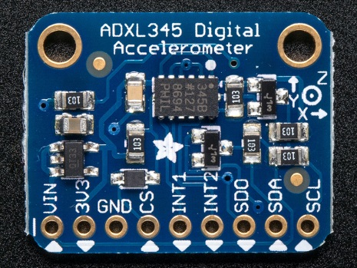Cost: $17.50
* Goal: Test accuracy, ease of use, and programming for accelerometer/tilt sensor
* Why: Accelerometers provide tilt/orientation information necessary for Exfloat; product allows for rapid testing/prototyping of accelerometer
* Features: +/- 2g, measurement of inclination changes less than 1.0°
* <https://www.adafruit.com/products/1231>